Flexible Ways to Bypass Windows 7 Password

Article Source:

http://recoverlostpassword.com/article/bypass-win7-password.html

As the latest release of Microsoft Windows, Windows 7 became more and more popular in terms of user friendliness, stability and functionality. With the increasing Windows 7 users, the question such as “how can I bypass Windows 7 password” is getting more frequently asked. To meet their requirements, today I would like to share some ways to bypass Windows Password.

Way One: Bypass Windows 7 password in Safe Mode
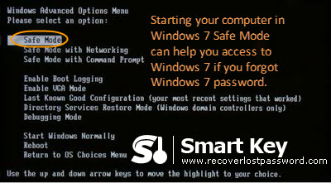
Starting your computer in Windows 7 Safe Mode can help you access to Windows 7 if you forgot Windows 7 password.
- Restart your PC, and press the “F8” key before the Windows 7 splash screen appears. The time is very short, you need to press it as quickly as possible and never miss. Otherwise, Windows 7 is probably continuing to boot normally. And you have to restart your computer and press “F8” again.
- You will enter “Advanced Boot Options”. Using the arrow key on your keyboard to highlight “Safe Mode” Option and press “Enter”.
- The account logon screen appears, and you must log on with the administrator password. The default administrator password is blank unless you reset it.
- Now your PC is in Safe Mode.

Now that you enter into Windows 7 Safe Mode, bypass Windows 7 password is just a piece of cake.
- Click on “Start”->”Control Panel”->”User Accounts and Family Safety”->”User Accounts”->”Change your password”.
- Respectively enter your new password in the first and second text boxes.
- It is optional to set a password hint. It is used to jog your memory if you enter the wrong password in the future.
- Confirm your changes by clicking on “change password”.

Way Two: Bypass Windows 7 Password with Software
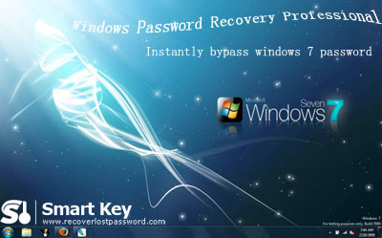
It is very useful to bypass Windows 7 password by starting PC in Safe Mode. However, you must handle basic computer knowledge to do like that. What the most important condition is that you must have administrator password. If you also lost Windows 7 administrator password, how should you do? We recommend Windows 7 Password Recovery to bypass Windows 7 Password without knowing administrator password.

Follow me to learn how it works:

Step 1: Prepare one computer which can log onto Windows with a blank CD inserted in. and launch Windows 7 Password Cracker.
Step 2: It is up to you to choose whether you reset password for local account or domain administrator (only for enterprise version).
Step 3: Specify the device (here we tick “CD/DVD”, you can also select “USB Flash Drive” if you connect USB in the Step 1).
Step 4: Click “burn” to start the bootable CD burning.
Step 5: Insert this CD on the computer you can’t access to and boot it from CD.
Step 6: You will enter the main interface of Windows 7 Password Recovery. Select the Windows installation and the user account you would like to reset password.
Step 7: Follow the wizard to remove password or create a new password.
Step 8: Reboot your PC to finish this password changing.

In a conclusion, Windows 7 Password is by far the best software to bypass Windows 7 password.

